***Types of users***

* Admin
* Employee

***Functionality of Admin***

* In dashboard they can see number of employees, pending leave application in total
* Create account and send email, password to his email
* View employee list
* View and Update employee information
* Deactivate employees
* View individual employee’s leave applications.
* View pending leave application list.
* Approve/Reject leave applications
* On approve/reject application Notify applicant with push notification and email
* Manage own profile (All information)
* Reset password
* Forgot password

***Functionality of Employees (Manager)***

* In dashboard they can see number of employees under him, pending leave
* Apply for leave
* application under him.
* View employee list under him/her.
* View employee details under him/her.
* View individual employee’s leave applications.
* View pending leave application list.
* Approve/Reject leave applications
* On approve/reject application Notify own manager (if any) or admin with push notification and email
* Manage own profile (Emergency contact number)
* View own leave applications.
* Reset password
* Forgot password

***Functionality of Employees (Normal)***

* Apply for leave
* On leave apply notify his manager with push notification and email
* Manage own profile (Emergency contact number only)
* View own leave applications.
* Reset password
* Forgot password

**ER Diagram:** 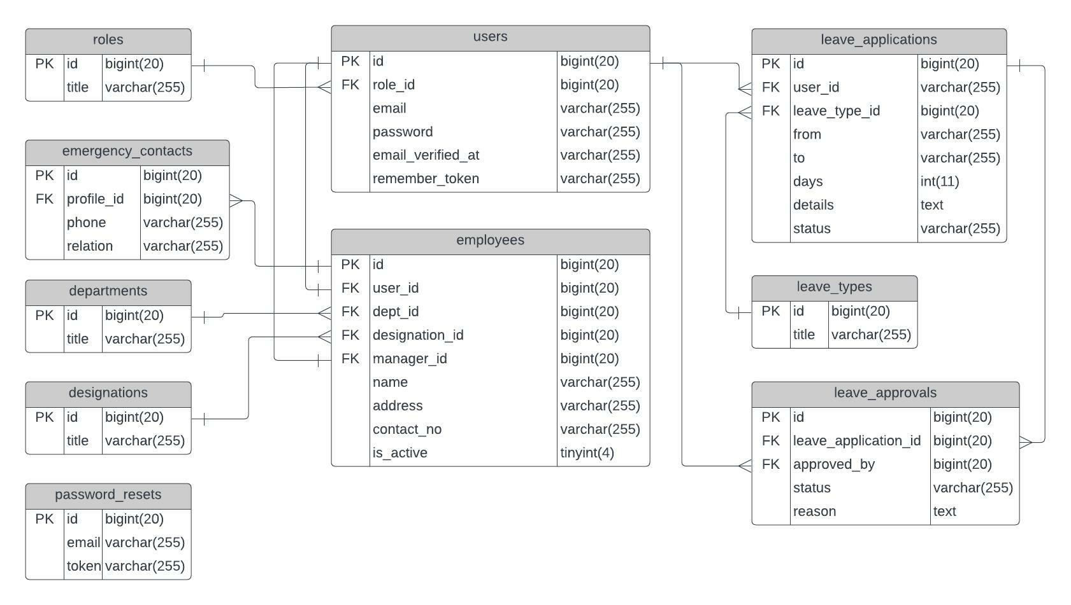

**View Pages:**

***Common Views:***

* **Login**
* **Forgot Password**
* **Reset Password**
* **Set Password**

***Views of Admin and HR:***

* **Dashboard (**Count of all employees, roles, designations, departments, pending leave applications**)**
* **Employee Adding Form**
* **Employee List**
* **Employee Detail with leave applications**
* **Pending Leave Applications**
* **Leave Application Details**
* **Profile**
* **Change Password**

***Views of Employee (Manager):***

* **Dashboard (**Count of all employees under him/her, pending leave applications under him/her**)**
* **Leave Applications form**
* **Employees under him/her**
* **Employee Detail (only under him/her) with leave applications**
* **Pending Leave Applications employees under him/her**
* **Leave Application Details employees under him/her**
* **Profile with own leave application**
* **Change Password**

***Views of Employee (General):***

* **Dashboard (**Count of all leave applications of his/her own**)**
* **Leave Applications form**
* **Profile with own leave application**
* **Leave Application Details of him/her**
* **Change Password**

**View Pages**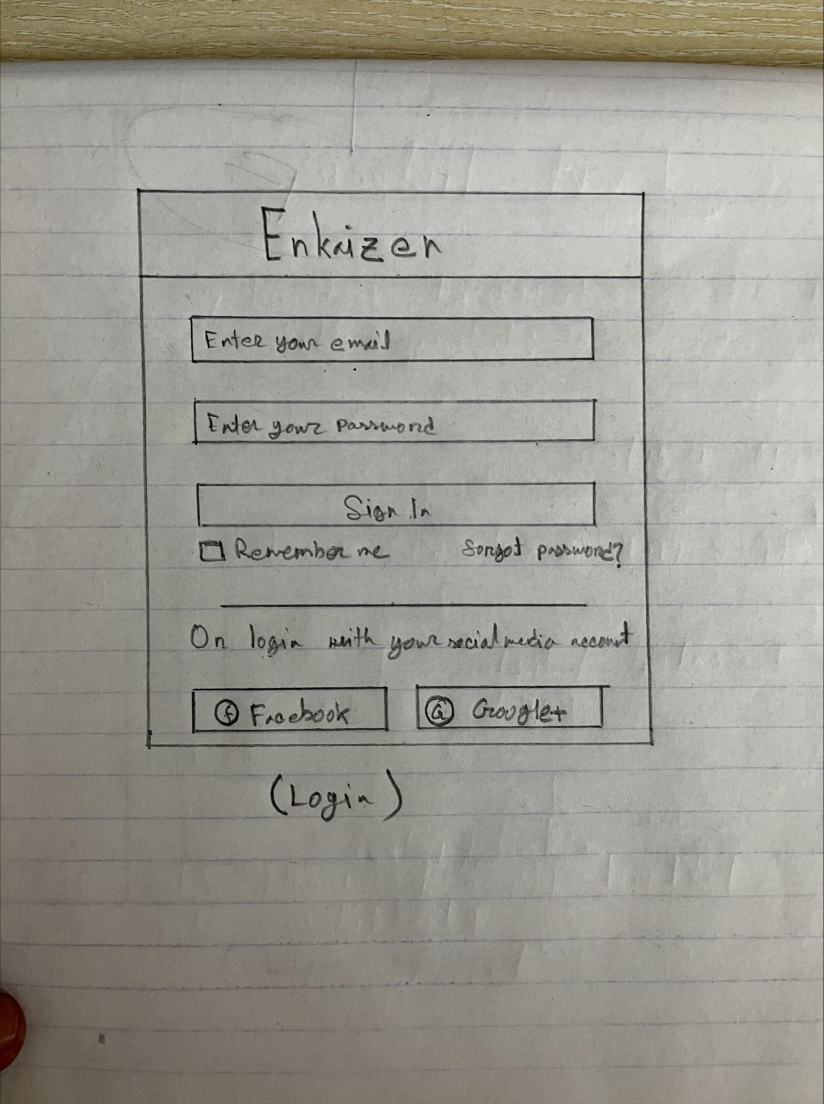

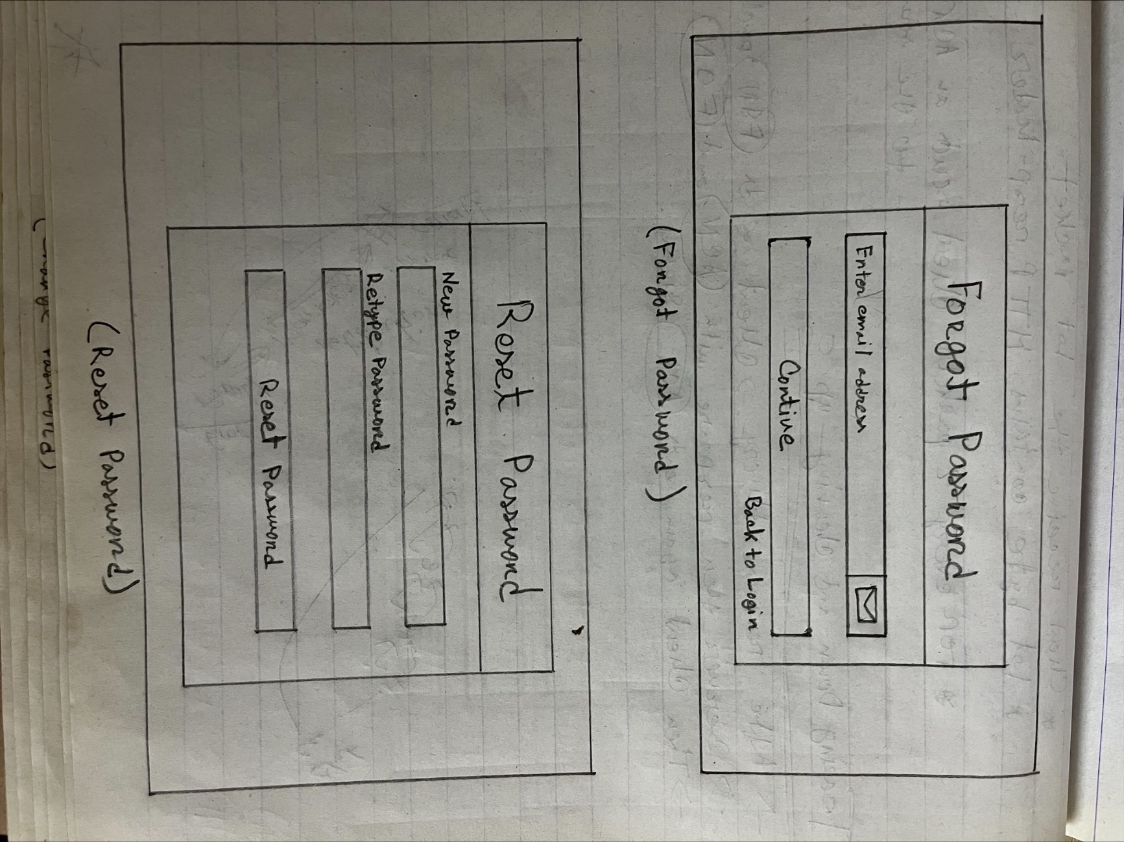

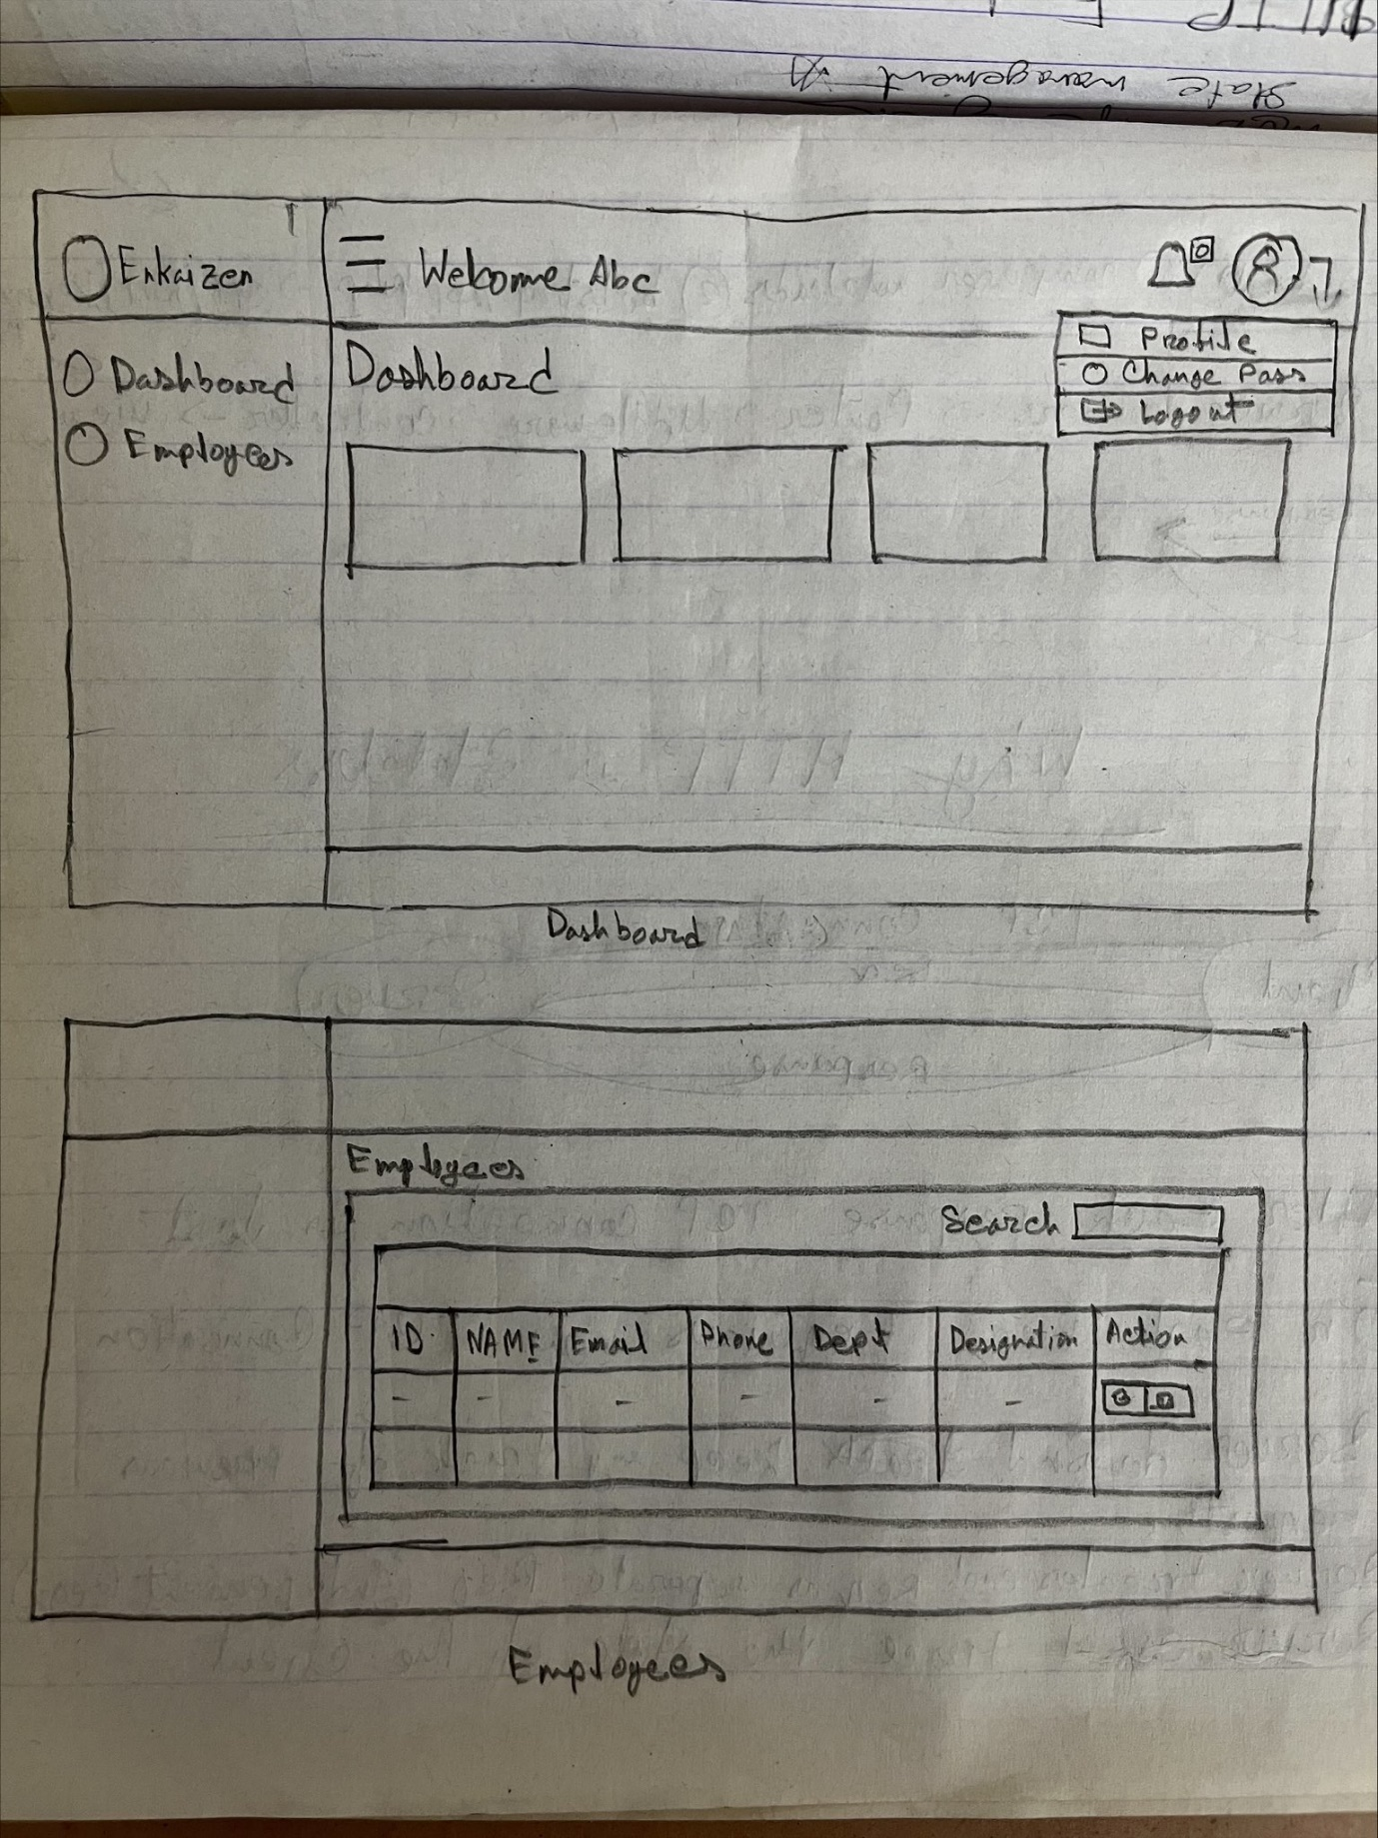

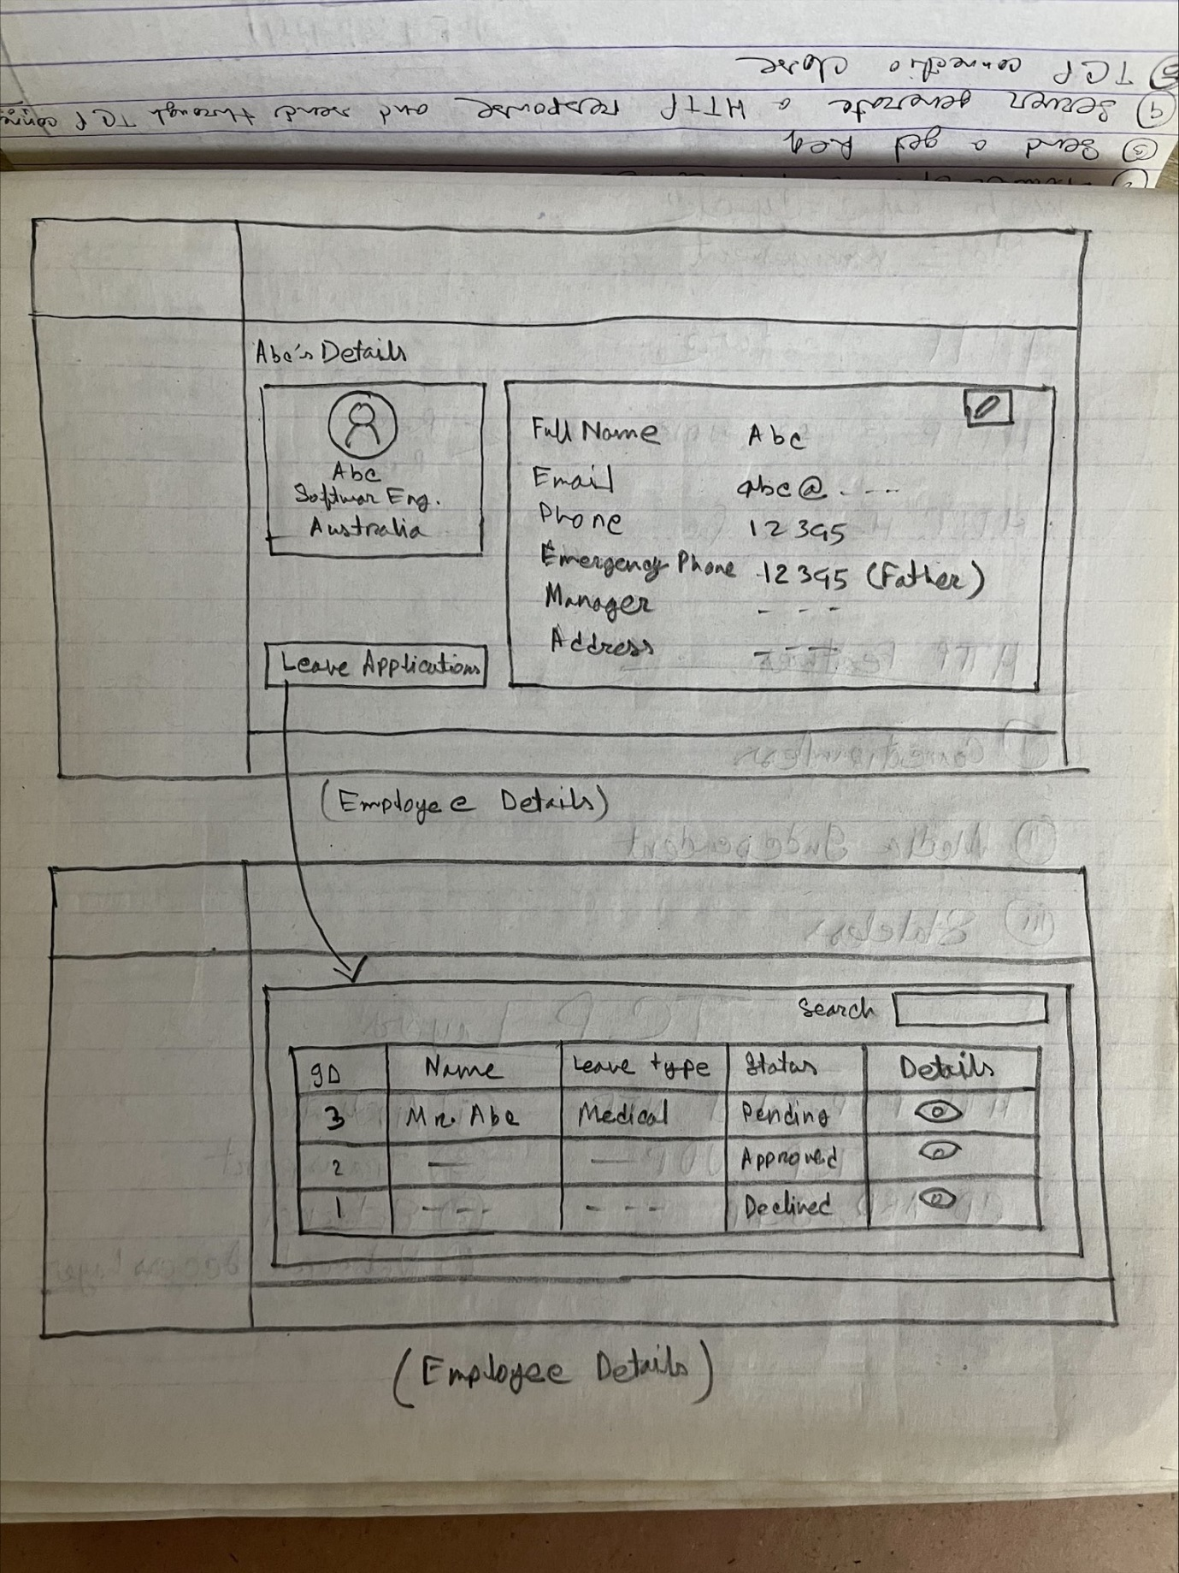

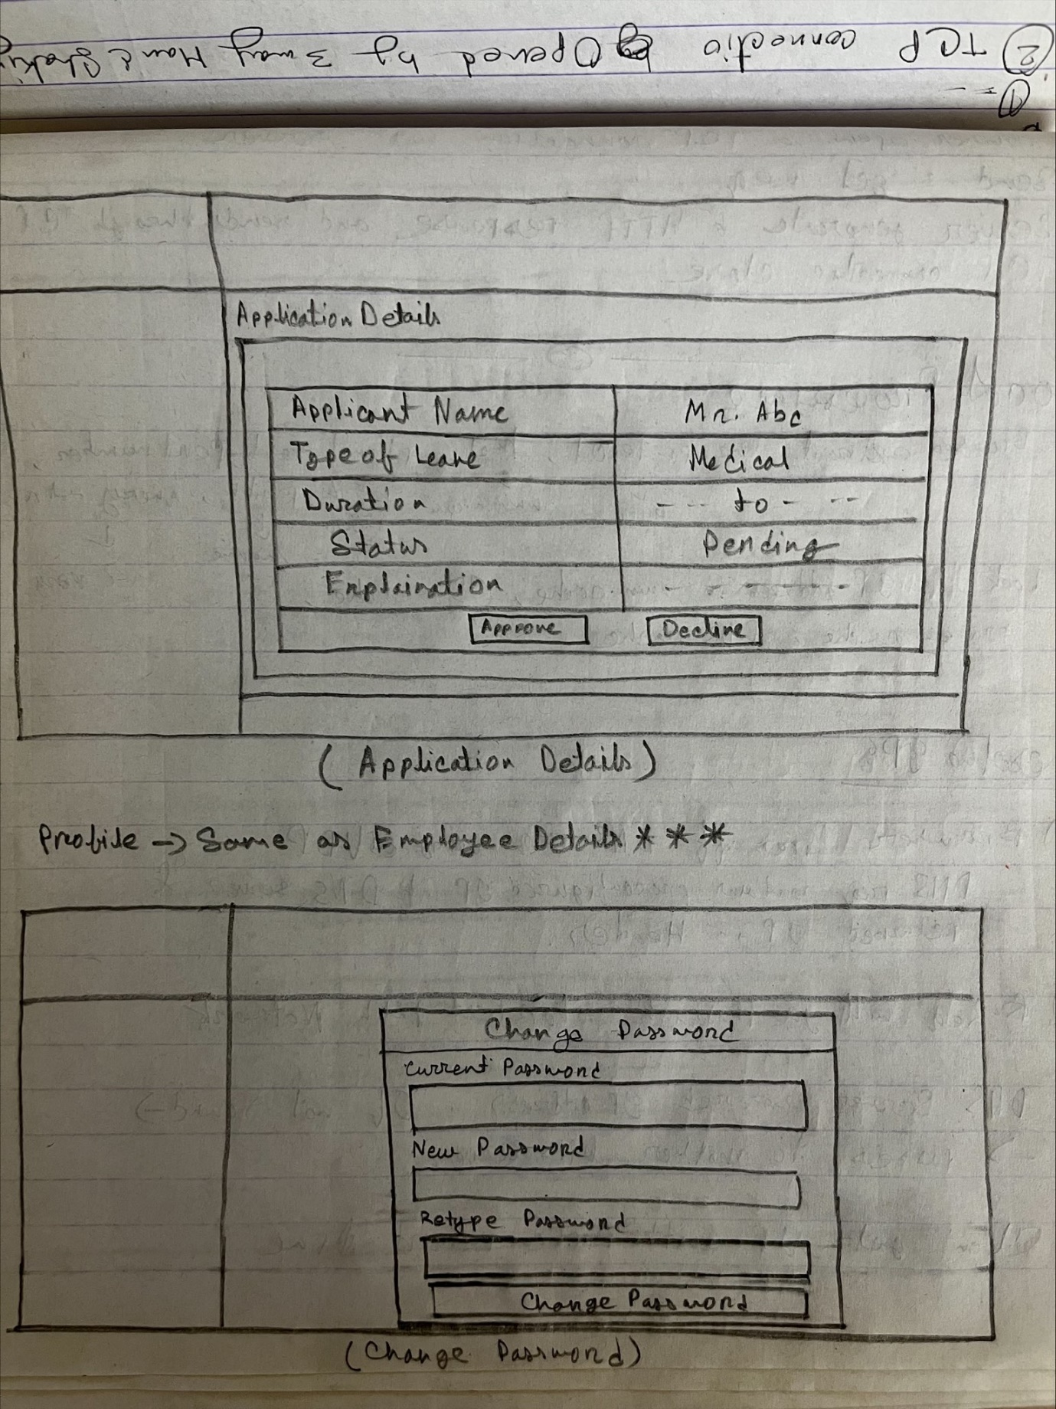

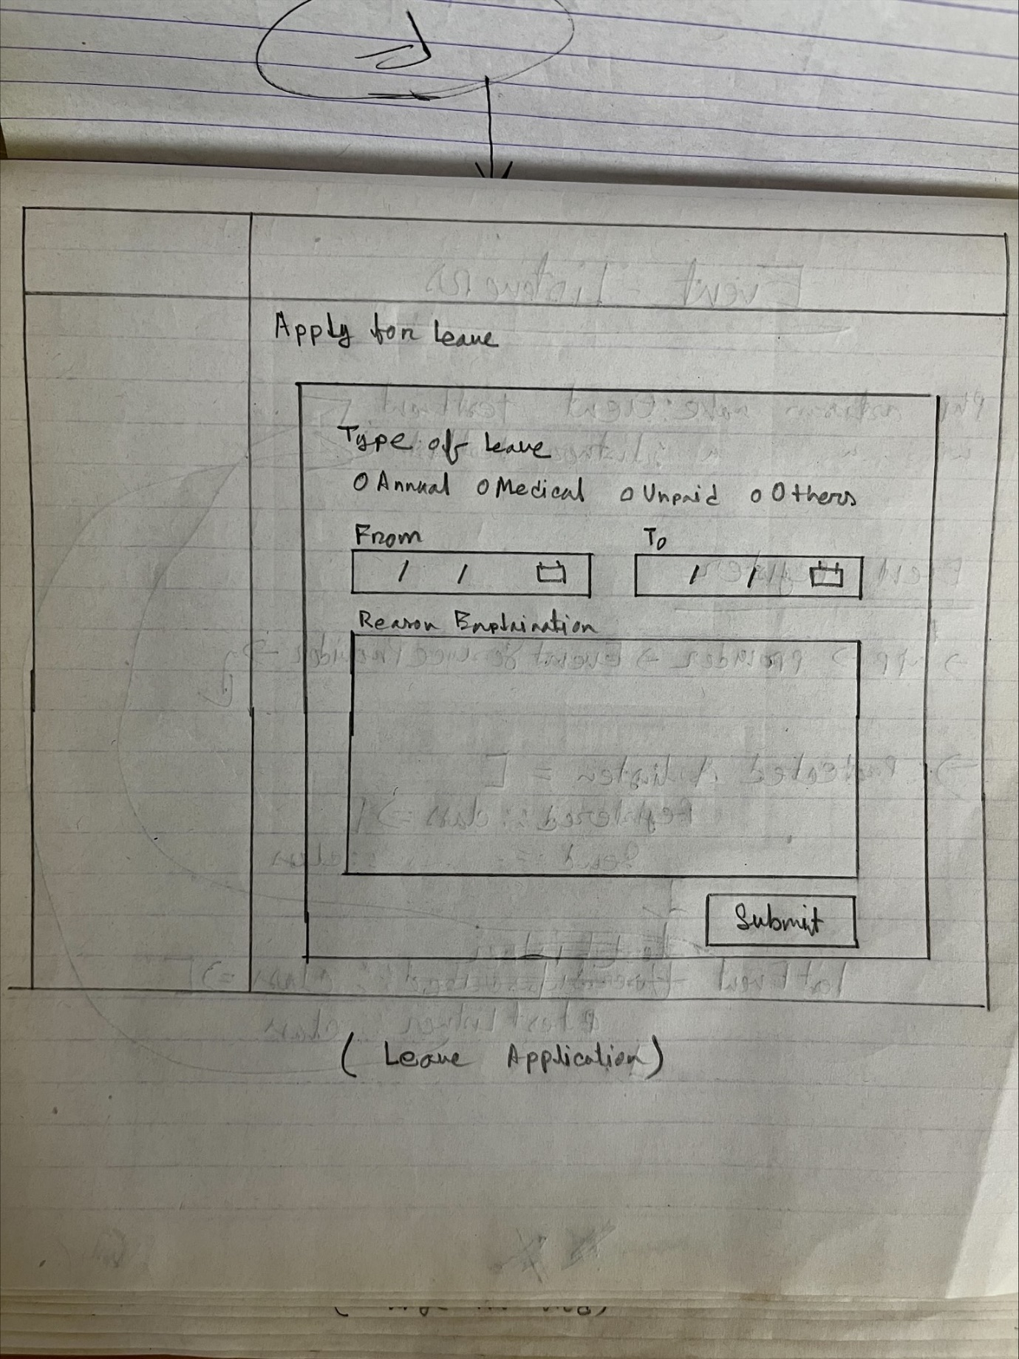

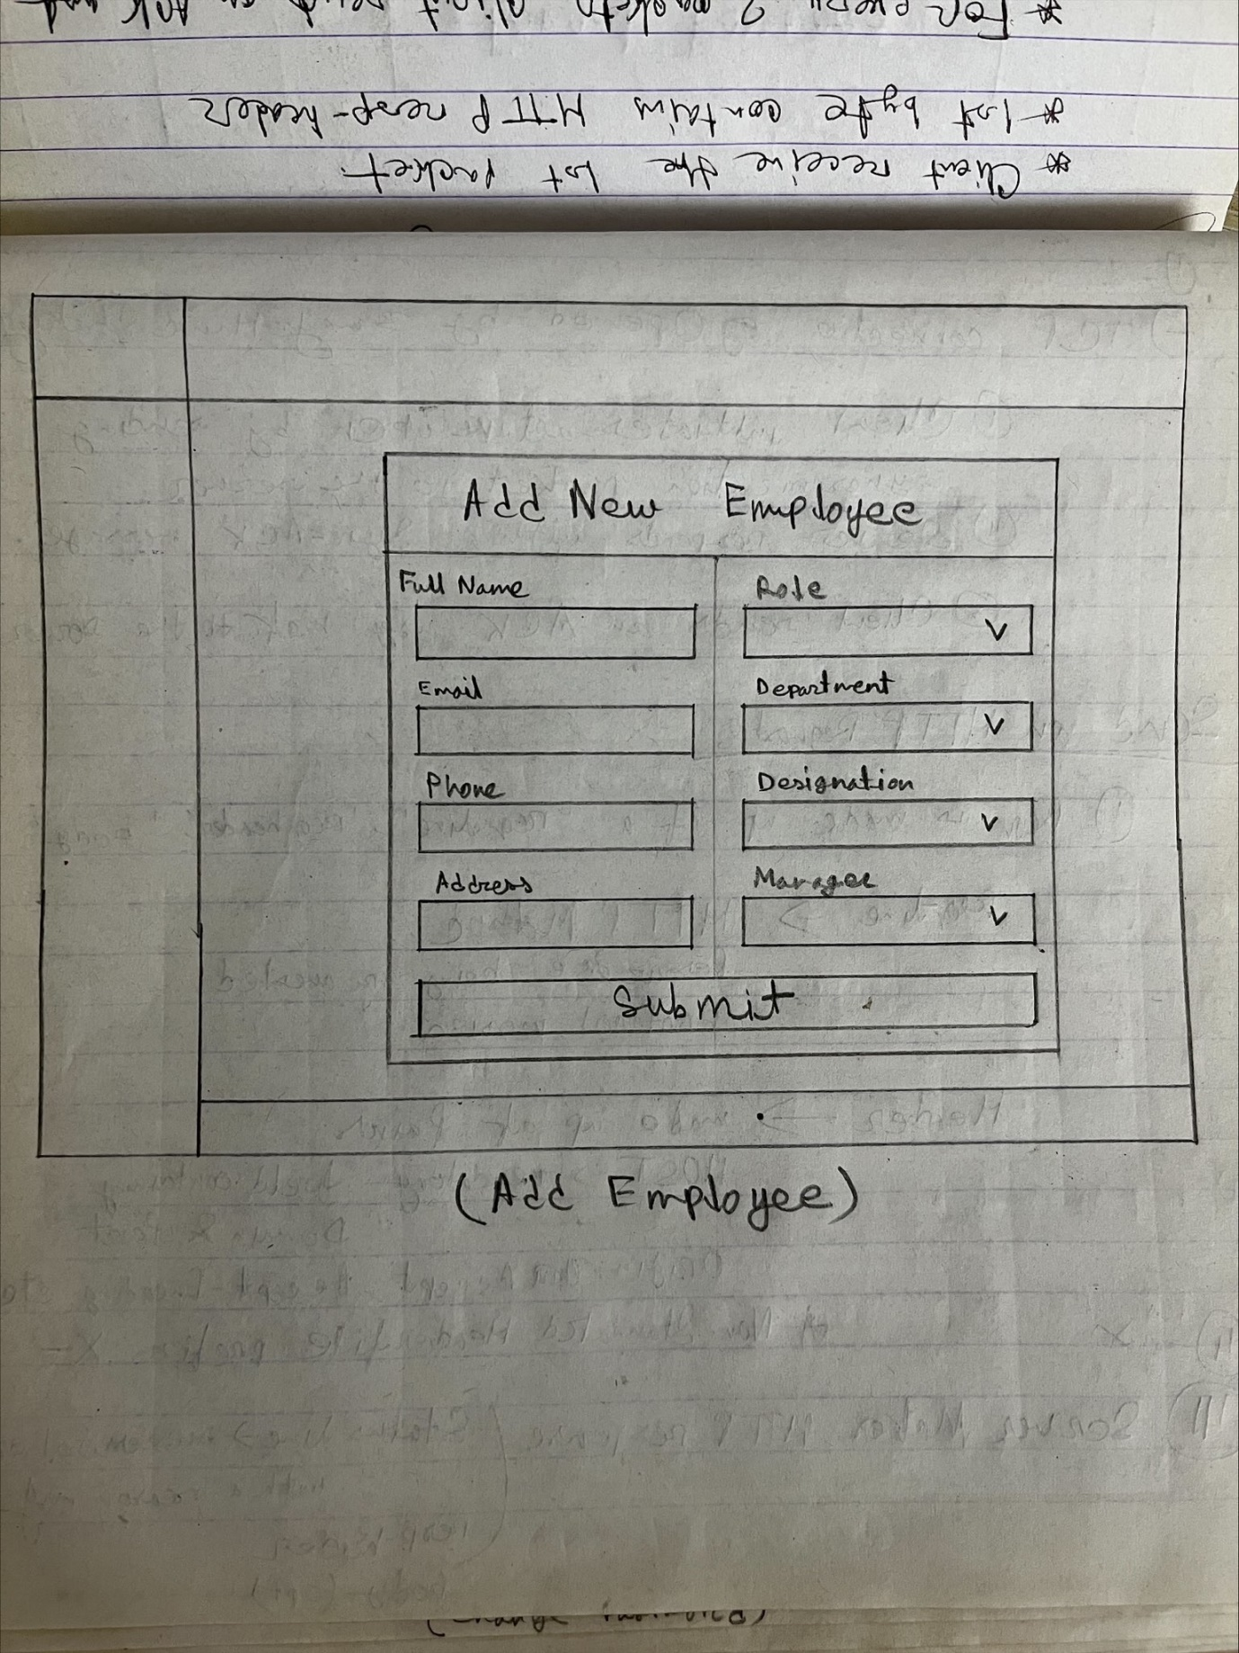

**API End-Points:**

POST /login (sends email and password)

POST /forgot-password (sends email)

POST /reset-password (sends email, token, new password)

POST /logout

**// Profile ##############################################**

GET /profile/{id} (get user’s all information with role, department and designation table and manager’s information)

PUT /profile/{id} (sends only new emergency contact number for **employees** and user’s full information for **admin** and **HR**)

POST /change-password

**// Employees ####################################################################**

POST /employees (sends new employee’s full information without emergency contact number)

GET /employees (get all user’s all information with role, department and designation table and manager’s information)

GET /employees/manage/{id} (get all user’s all information with role, department and designation table and manager’s information where manager_id = id)

GET /employees/{id} (get user’s all information with role, department and designation table and manager’s information where id=id)

DELETE /employees/{id}

PUT /employees/{id} (sends user’s full information where id=id)

**// Metadata ############################################################**

GET /metadata/dashboard (gets count of employees and pending applications)

GET /metadata/employee-details (gets count of role, designation and department)

GET /metadata/leave-types (gets all leave_types table’s data)

**// Leaves ##########################################################################**

POST /leave-applications (sends full leave information)

GET /leave-applications/user/{id} (gets leave_application table’s all data where user_id = id)

GET /leave-applications/{id} (gets leave_application table’s single data where id = id)

GET /leave-applications/pending/manager/{id} (gets pending leave applications of users under per manager)

GET /leave-applications/{id}/manager/{action} (here action = approve/reject)

GET /leave-applications/{id}/admin/{action} (here action = approve/reject)

**// Notifications ####################################################################**

GET /notification-list/user/{id} (Show notification for user where user’s notifiable_id=id from notification table)

GET / notification-list/{id}/read (Marks notifications as read for user by updating read_at column where notifiable_id=id from notification table)